

<<Project name>>
Software Requirement Document

– HCM, Jan 2024 –

Record of changeS
Date | A*  M, D | In charge | Change Description
13/Apr | A | KienNT | Thêm mô tả chức năng Setting Details (II.1.a)
*A - Added M - Modified D - Deleted

Table of Contents
I. Overview 4
1. Introduction 4
2. Existing Systems 4
2.1 System name1 4
2.2 System name2 4
3. Business Process 5
4. System Functions 6
5. Entity Relationship Diagram 7
6. State transition diagram 7
II. Functional Requirements 9
1. <<Feature Name 1>> 9
a. <<Function Name 1>> 9
b. <<Function Name 2>> 9
2. <<Feature Name 2>> 9
III. Database Design 10
1. Database Schema 10
2. Table Detail 10

I. Overview

1. Introduction
[Content part 1: presents a high-level overview of the product and the environment in which it will be used, the users, and known constraints, assumptions, and dependencies]
[Content part 2: describes the product's context in the form of a context diagram in which you present the boundary and connections between the system you’re developing and everything else in the universe. This identifies external entities (or terminators – software, hardware, human components, and other systems) outside the system that interface to it in some way, as well as data, control, and material flows between the terminators and the system]
<<Sample: The Cafeteria Ordering System is a new software system that replaces the current manual and telephone processes for ordering and picking up meals in the Process Impact cafeteria. The system is expected to evolve over several releases, ultimately connecting to the Internet ordering services for several local restaurants and to credit and debit card authorization services.
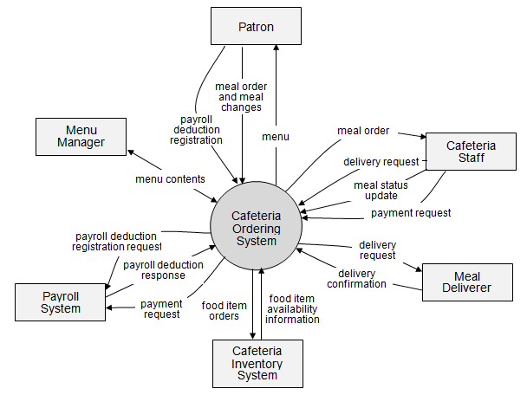>>

2. Existing Systems
[Add the system which might help solving the problems you listed above or the systems in which you can learn/refer the features for your system design]

2.1 System name1
[Write the brief descriptions of the system, the link, the system actors, features, pros, cons, etc.]

2.2 System name2
…

3. Business Process
[This part shows business processes of the system, using swimlane diagram]
<<Sample: shows a partial swimlane diagram for the CTS. The swimlanes in this example are roles or departments, showing which group executes each step in the business process to order a chemical from a vendor.
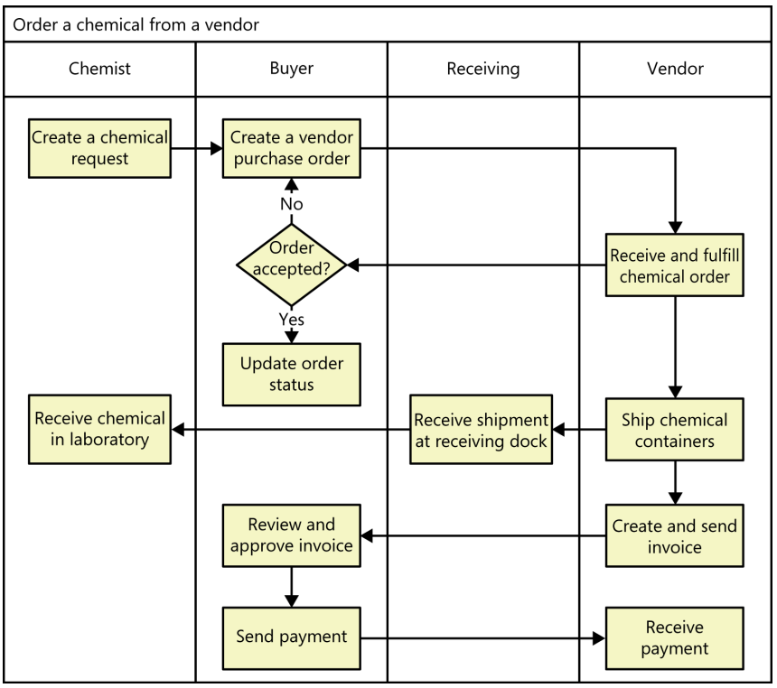
# | Process Step | Description
1 | Create a chemical request | <<Process Step description>>
2 | Create a vendor purchase order
3 | …
>>

4. System Functions

a. Screen Flow
[This part shows the system screens and the relationship among screens. You can draw the Screens Flow for the system in the form of diagram as below]
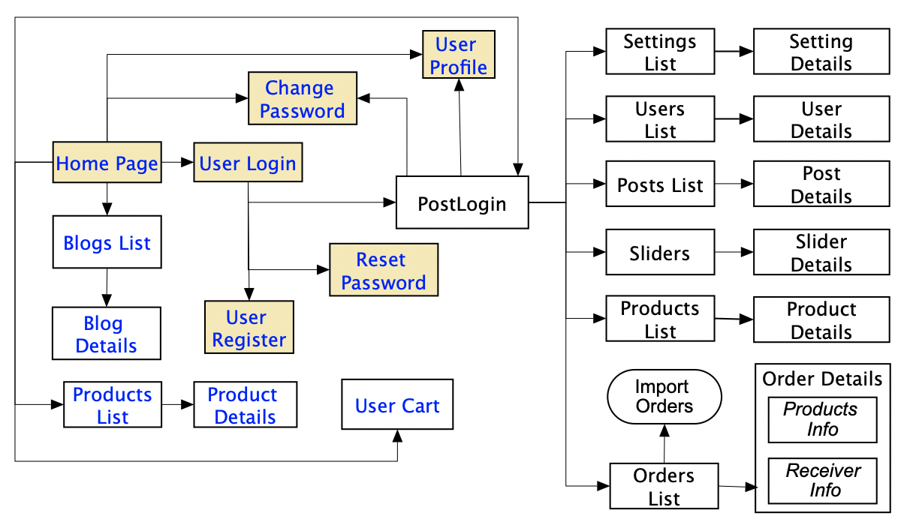

b. Screen Details
[Provide the descriptions for the screens in the Screens Flow above]
# | Feature | Screen | Description
1 | Order Meals | Create Order | <<Screen Brief description>>
2 | Order Meals | Change Order
3 | ..

c. User Authorization
[Provide the system roles authorization to the system features (down to screens, and event to the screen activities if applicable) in the table form as below – replace Role1, Role2,… with the specific system user role names]
Screen | Role1 | Role2 | Role3 | Role4 | RoleX
<<Screen Name1>> | X |  |  | X | X
<<Screen Activity>> |  |  |  | X | X
<<Screen Name2>> | X |  |  | X
Query All Data | X
Query Own Data |  |  |  | X
Query Managed Data |  |  |  | X
Add New Data |  |  |  | X | X
Update All Data |  |  |  |  | X
Update Own Data |  |  |  |  | X
Update Managed Data |  |  |  |  | X
Delete Data
…
In which:
- Role1: <<role1 description>>
- Role2: <<role2 description>>
- …

5. Entity Relationship Diagram
[Provide the entity relationship diagram and the entity descriptions in the table format as below]
Entities Description
# | Entity | Description
1 | User
2 | Meal
3 | Meal Subscription
4 | …

6. State transition diagram
[This part shows state transition of main entities in the system]
<<Sample: a state-transition diagram that shows the possible meal order statuses and the allowed changes in status.
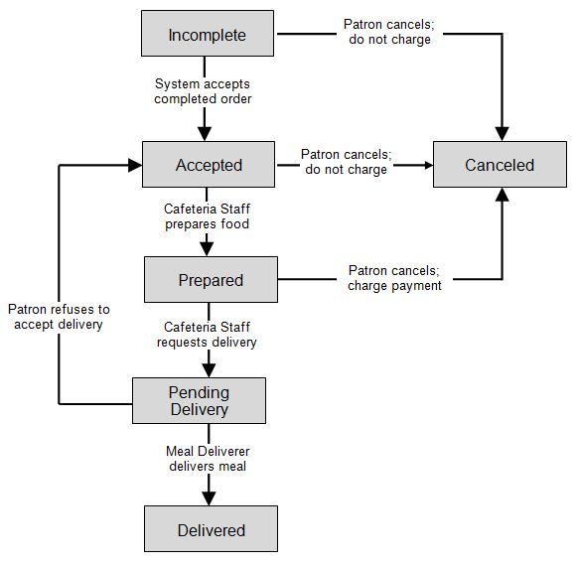
>>

II. Functional Requirements

1. <<Feature Name 1>>

a. <<Function Name 1>>
[A function can be a screen or a non-screen function (listed in the part I.2.d above). In this part, you need to provide the details on the related function, focus on mentioning below information
- Function trigger: how this function is triggered (navigation path, a timing frequency, etc.)
- Function description: actors/roles, purpose, interface, data processing, etc.
- Screen layout: mockup prototype of the screen, sample below is for Manage Products screen
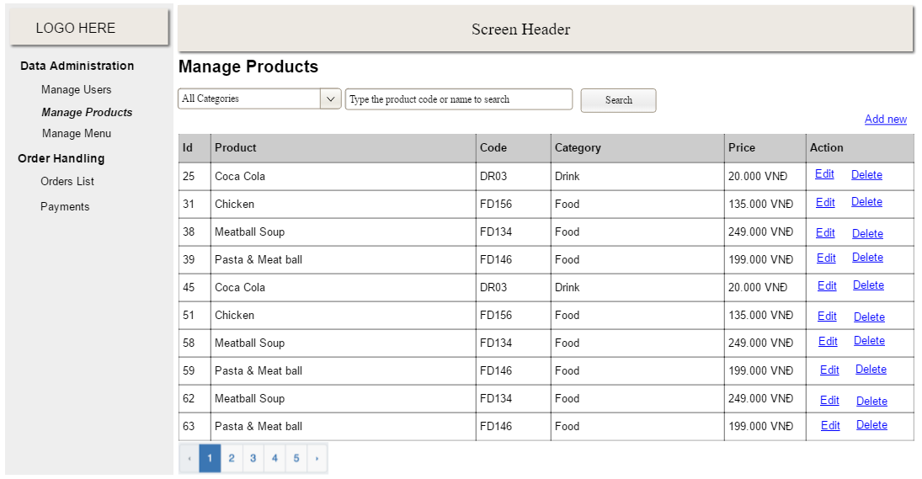
- Function Details: provide explanation for the data, validation, business logics, functionalities (for both normal cases and abnormal cases), etc. of the function so that the reader can image how it work.
]

b. <<Function Name 2>>
…

2. <<Feature Name 2>>
…

III. Database Design

1. Database Schema
[Provide the tables relationship like example below – following MySQL database naming convention]
Table Description
No | Table | Description
1 | <Table name> | <Description of the table>
2 | <Table name> | <Description of the table>
3 | …

2. Table Detail
[Give some lines about the table here>>
[Table fields, in the form of table format as below]

<< Table Name 1 >>
# | Field name | Type | Size | Unique | Not Null | PK/FK | Notes
1 | Field name1
2 | Field name2

<< Table Name 2 >>
# | Field name | Type | Size | Unique | Not Null | PK/FK | Notes
1 | Field name1
2 | Field name2

